USING :

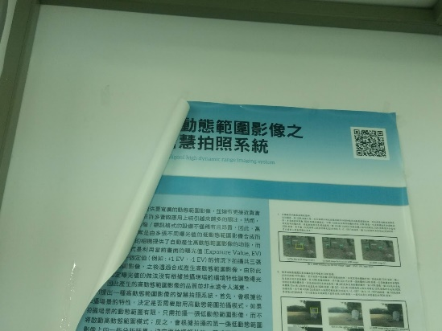 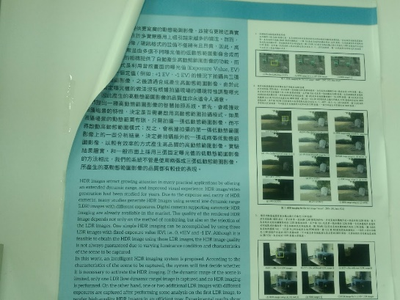

Number of keypoints : 18325 (for both)

After matching and applying lowes ratio(0.75) : len(good) is 1287

Image of matched points (after lowe)

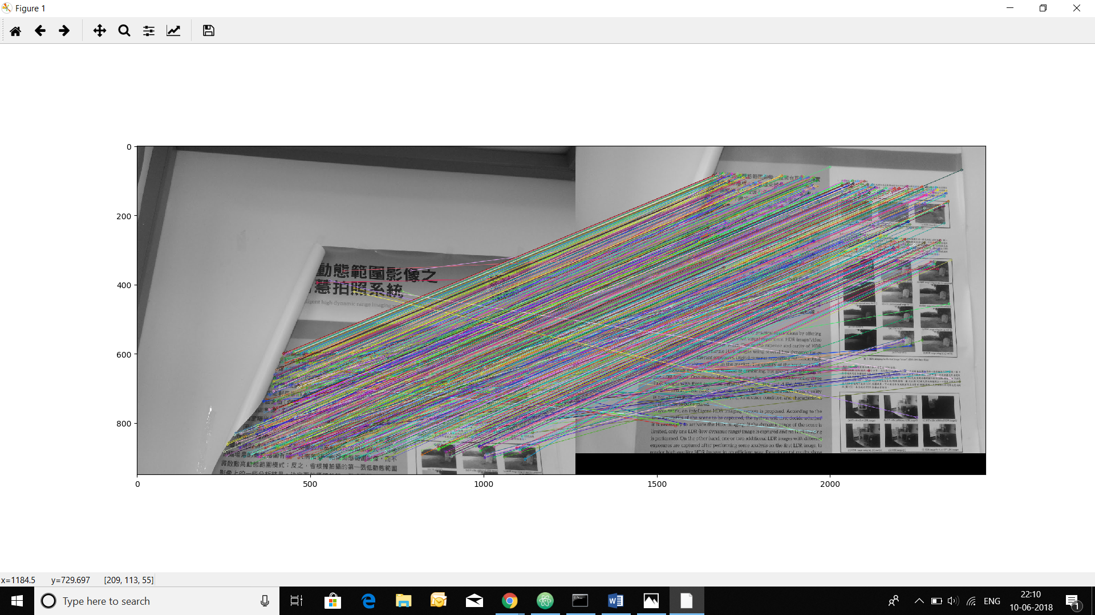

USING:

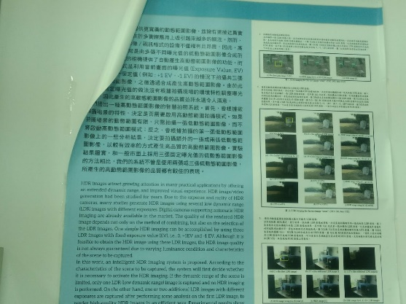 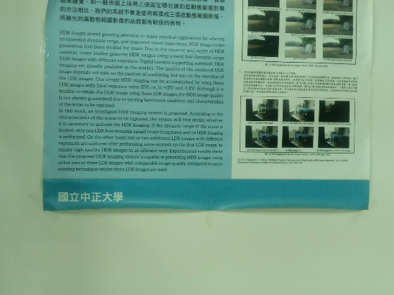

Number of keypoints = 21604

Len(good) = 3003

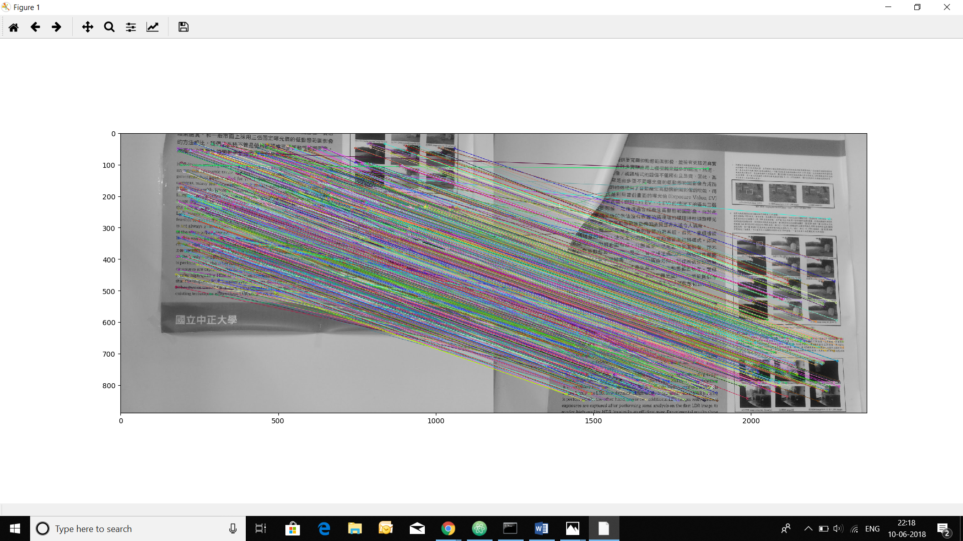

USING : (highly wrong matching )

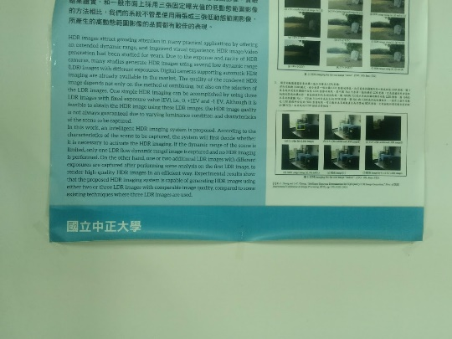 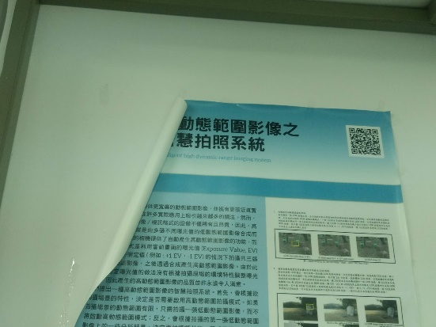

Number of keypoints : 21604

Len(good) = 440

